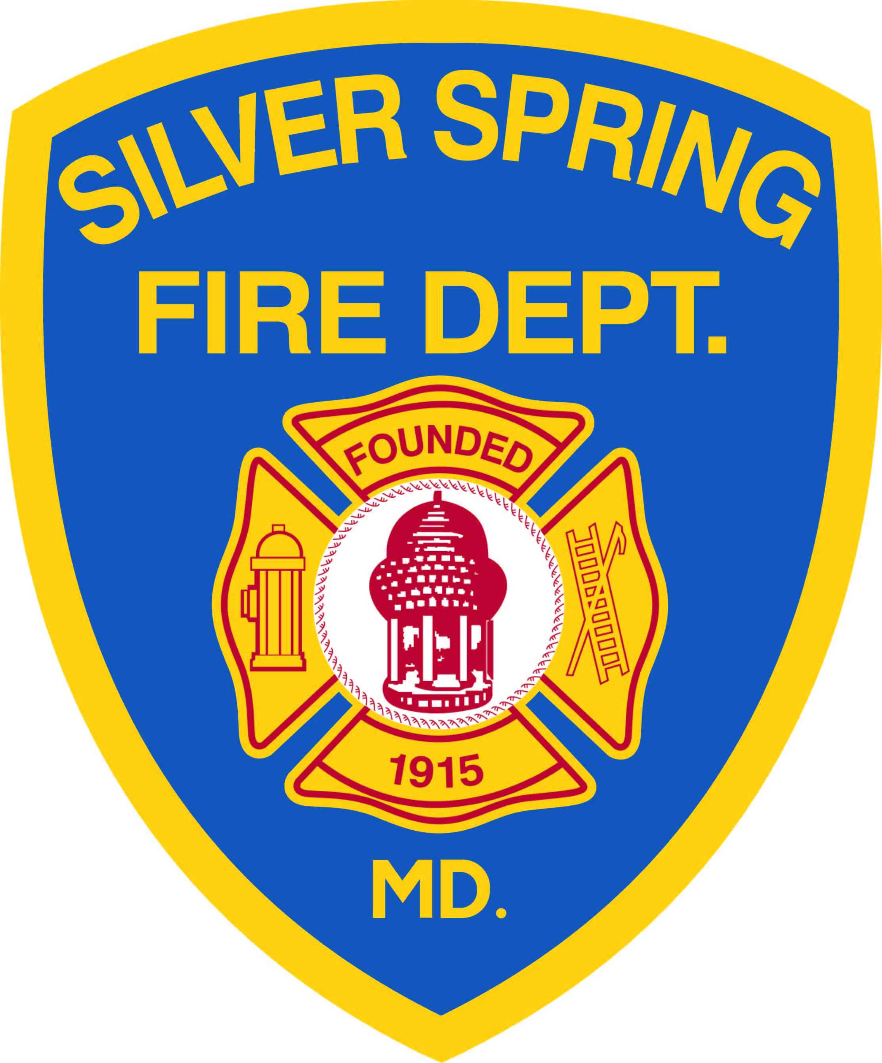
The Life Safety Unit
of the Silver Spring Volunteer Fire Department will present
Home Safety for Seniors
Thursday, September 26, 2013
At 10 am
Clifton Park Baptist Church
8818 Piney Branch Road
Silver Spring, Maryland

Information on how to make your home safer by preventing falls and fires will be provided. Free home safety checkups, installation of 10 year battery smoke alarms, assistive alert devices for the deaf and hard of hearing and CO detectors will also offered. This program is part of the Safe Homes Silver Spring Initiative a fire prevention \home safety program funded through a FEMA grant.

